Regulations Governing the Anchorage of Vessels in Suao International Commercial Port, Taiwan International Ports Corporation, Ltd. (TIPC)

- Objectives
“Regulations Governing the Anchorage of Vessels in Suao International Commercial Port, Taiwan International Ports Corporation, Ltd.” is herein stipulated to prevent the vessels occupying the anchorage outside the port for a long period of time, which may result in the lack of anchorage for inbound/outbound vessels; to enhance the use efficiency of anchorage managed by Port of Suao, to ensure the navigation safety of vessels; and to enhance the management of anchoring area.
- Anchoring area (As illustrated in Attachment 1)
Anchorage of the Suao Port is at a distance of 1 – 1.5 miles N of the north-breakwater. The range of the anchorage, within the connecting lines of points A`-B`-C`-D`, is indicated on CN Charts No. 0354B (WGS-84) published by the Chinese Naval Hydrographic & Oceanographic Office. Its depth is about 16-26 meters. The seabed is sandy and anchoring area is waters formed by points from A to D:
Point A`: Lat24°35’24”N、Long121°53’02”″E (WGS-84)
Point B`: Lat24°35’ N、Long121°53’53”E (WGS-84)
Point C`: Lat24°34’23”″N、Long121°53’20”E (WGS-84)
Point D`: Lat24°35’9.5”N、Long121°52’50.5”E (WGS-84)
Suao port Second anchorage area:
Point A`: Lat24°34’23”N、Long121°53’20”″E (WGS-84)
Point B`: Lat24°34’22 ”N、Long121°53’37”E (WGS-84)
Point C`: Lat24°34’06”″N、Long121°53’21”E (WGS-84)
Point D`: Lat24°34’06”N、Long121°53’37”E (WGS-84)

Use: To meet the demand of vessels proceeding in and out for anchoring.

- Application for anchoring
- Inbound vessles
- Object: Vessels whose arrival has been reported to the Maritime and Port Bureau in advance and who is waiting for a berth.
- Duration in anchorage: According to arrangement of the berth in the port, the principle is 2 days.
- Outbound vessels
- Object: Vessels that need to stay in the anchoring area for a short period of time due to business needs.
- Duration in anchorage: Should not exceed 1 day unless approved by port of Suao.
- Vessels that shift berth
- Object: Vessels that stay in the anchoring area for a short period of time due to business needs, and need to enter the port again.
- Duration in anchorage: Should not exceed 1 day unless approved by port of Suao.

- Anchor on arrival：
- Object: Vessels that do not enter Port of Suao and only stay in the anchoring area for a short of time due to business needs (supply, repair, crew replacement, emergency medical, stand by , take shelter from the wind and so on).
- Duration in anchorage: The principle is prohibited unless approved by port of Suao.
- The above-mentioned vessels shall leave the anchorage immediately after has been fulfilled, that would be beneficial to the assignment of anchorage, except nationality of the R.O.C.

- Application procedures：
Firstly, the vessels shall apply permission for anchoring through the computer system. When the system failure, the vessels may fax the written application (please refer to Attachment 2 for the application form) to the monitoring center (fax number: 03-9964591) and then register the application in the system afterwards.

- Anchoring procedures
Vessels shall choose an appropriate anchor position according to the suggestion of VTS center and keep a safe distance from other vessels. Before anchoring, vessels shall confirm their location with VTS center. Upon anchoring, vessels shall report their anchor position and time to the VTS center.
- Prohibition of anchoring
Where the anchoring area or vessel complies with any of the following conditions, TIPC may prohibit the vessel from anchoring in the anchoring area:
- The vessel fails to commission a shipping agent to apply for anchoring.
- There is no appropriate place for dropping anchor and the vessel is unable to keep a safe distance from the others.
- The vessel’s AIS fails, or has been turned off, or the display data is not in line with application form and cannot be verified or confirmed.
- The vessel suffers from drift anchor and, after attempting to anchor again, but fails to keep its anchor location.
- The vessel is on the embargo list of United Nations Security Council and the following list of Maritime and Port Bureau, Ministry of Transportation and Communications (MOTC).
- Vessels of the mainland China that enter the anchoring area without permission.
Anchored or detoured near the non-anchorage, and not obey driven away by the VTS ,will temporarily stop the anchor application 3 weeks and send the list of vessel to the Maritime and Port Bureau.
- Early warning mechanism:
- After the Central Weather Bureau (CWB) issues the sea/land warning for typhoon, works prescribed in “Principles for Vessel Berthing Operations during the Typhoon Period” shall be conducted. Besides, as an early warning mechanism, shipping agent in the port area shall be notified in order to be prepared for the typhoon.
- After the Central Weather Bureau (CWB) issues a tropical depression (where the max. wind speed close to the center equals to or is smaller than 33 nautical miles per hour (17.1 m / second, or the wind level is smaller than 7) or sea gale (where the average wind level is above 6) warning, TIPC will adopt the following measures in response:
- Notify the shipping agents to timely control the vessel dynamic. If the belong thereto vessels desire to enter the port, it must to make an arrangement accordingly as early as possible.
- Send gale related message of the AIS, reminding the vessels to pay attention to anchor watch and make main engine standby at any time.
- The VTS will activate the clearance mechanism of the anchor area according to indication.
- The on-duty personnel of the VTS center shall enhance the monitoring of vessels in the anchoring area. Where any abnormality or danger happen as evaluated, it must to warning vessels in an appropriate way.

- Reporting and response procedures
Where any of the following circumstances occurs, the VTS center will, according to the Commercial Port Law and TIPC’s disaster prevention and rescue plan, conduct relevant response actions and inform TIPC’s monitoring center to report it to relevant units:
- The Vessels that comply with conditions of the anchoring prohibited in Article 4, enter or stay in the anchoring area without a permission, and fail to follow the instructions of VTS center to leave the area.
- Vessels that anchor in the anchoring area fail to keep a safe distance from other vessels or no switch on AIS, and fail to make an improvement upon receiving the warning of VTS center.
- Vessels that anchor in the anchoring area the anchor drift, collision with other vessels , or has a risk of stranded due to continue to drift to the shore.
- Other maritime incidents.

- Management of sub-standard vessels
- Upon confirmation of the sub-standard vessel list provided by Maritime and Port Bureau, sub-standard vessels will be arranged an appropriate anchorage when they enter the anchoring area for mooring.
- During the anchoring, sub-standard vessel above-mentioned shall keep power ready at any time and shall not remove the main engine. In the meantime, VTS center will enhance the monitoring of the vessels.
- Sub-standard vessel apply for anchoring please followed Article 3.

- Important notice
- During the anchoring period, vessels shall have sufficient crews to stay in the vessel and shall have the AIS switched on. Whether in day or night, the bridge shall have an on-duty officer keep radio watch on VHF channels 14 and 16 at all the time.
- During the anchoring period, the vessels shall comply with the following terms for their own safety:
- Where the weather is bad or there is any safety concern, it must not to dismantle or repair machines that are related to the power of vessel.
- Vessels that require maintenance works or repair, it must to acquire permission from the VTS center.
- During the anchoring period, discarding garbage (including kitchen waste) or discharging oily water or ballast water is prohibited. All waste oil, wastes and other contaminants shall be reserved in the vessel or discharged to relevant land facilities. Those who violate this provision will be sent to Maritime and Port Bureau in accordance to Articles 37, 38 and 63 of the Commercial Port Law for punishment.
- Upon completing the anchoring mission, the vessels shall immediately depart the anchoring area. Those who fail the instructions of VTS center will be sent to Maritime and Port Bureau in accordance to Articles 37 and 67 of the Commercial Port Law for punishment.
- In case of lacking anchorage, the VTS center will, according to the vessels’ location and order of applications, request the captain to wait outside the anchoring area.
- All types of vessels that enter the anchoring area shall drive to and moor in the anchorage designated by the port of Suao, TIPC. Those who violate the above condition, will have their rights to anchor cancelled if the situation is deemed serious. Where the above vessels result in a danger of the anchoring area or other vessels, the vessels will be sent to Maritime and Port Bureau for tribunal.
- During the anchoring period, vessels shall ensure that there is always a watchman in the vessel and pay attention to their navigation safety. Where any accident occurs due to the negligence of the vessel, the vessel shall be solely liable therefore. The anchoring area is only provided for vessel anchoring; the vessels are not under the custody of the port of Suao, TIPC and the port of Suao, TIPC is not liable for any damages thereof.
- To maintain the order and management of anchoring area, the Maritime and Port Bureau, port of Suao, TIPC, Environmental Bureau of Yilan City Government and Coast Guard Administration (CGA) may accompany the shipping agent to inspect the vessel. Where the vessel violates relevant laws or regulations, the competent authority will sanction by law or request the vessel to leave the anchoring area.
- Second anchorage area is also for vessel of Hoping Port. If the waves of off shore in Hoping Port is too strong to anchor, please anchor at second anchorage area in off port of Suao Port. Please notify the information of the vessel to Suao Port Control one day before the anchorage in principle for the help of anchoring. Besides, Suao Port Control only offers the relative information service. The safety in the period of vessel in anchor area and anchorage area should be on one's own account.

- Remark
- Article 33 of the Commercial Port Law：A ship which is navigating or berthing in a commercial port area, shall comply with the rules of prevention of collision and other relevant regulations provided by the commercial port authority.
- Paragraph 1 of Article 37 of the Commercial Port Law:：The following acts that pollute the commercial port are prohibited within a commercial port area: Ships that emit toxic liquids, toxic substances, harmful substances, sewage, oil and water or other contaminants.
- Article 38 of the Commercial Port Law: Waste oil, waste, or other pollutants of ships within the commercial port area should be kept on the boat or emission to the reception facilities on shore.
- Article 44 of the Commercial Port Law: Article 15 to Article 20, Article 23 to Article 25, Article 28 to Article 34, Article 36 to Article 40, that are relevant to ship entrance and departure, berthing, suspending ship service, hindrance of port safety, port pollution, hinder of loading and unloading of port facilities and dangerous items, control of ships encountering danger or taking refuge , and management of ship repair etc. port management regulations, should be stipulated by competent authority.
- Article 63 of the Commercial Port Law: When Violation of Article 37, Paragraph 1 and Article 38 , a fine ranging from three hundred thousand New Taiwan Dollars (NT$300,000) to one point five million New Taiwan Dollars(NT$1,500,000) can be issued to the master or ship owner by commercial port authorities or Designated Agency. An order to make improvements within a limited of time may also be granted. If no improvements have been made by then, they will be fined per violation.
- Article 66 of the Commercial Port Law: When Violation of relevant port management items in Article 44, a fine ranging from one hundred thousand New Taiwan Dollars (NT$100,000) to five hundred thousand New Taiwan Dollars(NT$500,000) can be issued by commercial port authorities.
- Article 67 of the Commercial Port Law: When Violation of Article 33, a fine ranging from one hundred thousand New Taiwan Dollars (NT$100,000) to five hundred thousand New Taiwan Dollars (NT$500,000) can be issued by commercial port authorities.
- Article 52 of the Regulations on Port Services at Commercial Ports: To ensure safety, machinery relating to the mobility of the ship in the anchorage may not be repaired during bad weather or when there are potential safety concerns.

Anchorage Application Form of Suao
To: Vessel Traffic Service Center (VTS)
The vessel of which our company acts on behalf is expected to arrive at anchorage area outside the port, and hereby apply for permission to drop anchor at anchorage area. During her stay at anchorage, the vessel will comply with regulations of the Port and our company will be liable for responsibilities related thereto and conduct all paper works. Our company will also supervise and assist the vessel complying with all port and navigation policy and regulations.
Details of the said vessel are as follows:
Vessel Name (Chinese and English):
Vessel Call Sign:
Vessel Type:
Vessel Length (total): m
Vessel Nationality:
Total Tonnage:
International Maritime Organization (IMO) Number:
Maximum Draft in the Port Area: m
Estimated Time of Arrival:
Expected Number of Days of Stay:
Whether the vessel has AIS (Automatic Identification System):
Whether the vessel has hazardous objects:
Whether the vessel has valid P&I document:
The last date of mooring in the anchoring area (blank if it has not been moored therein):
The Applicant Shipping Agent:
Name of the Contact Person:
Company Telephone No.:
Mobile Phone No.:
Client’s Code registered at Maritime and Port Bureau (4 digits):

(Seals of the agent)

Date:____/__/____
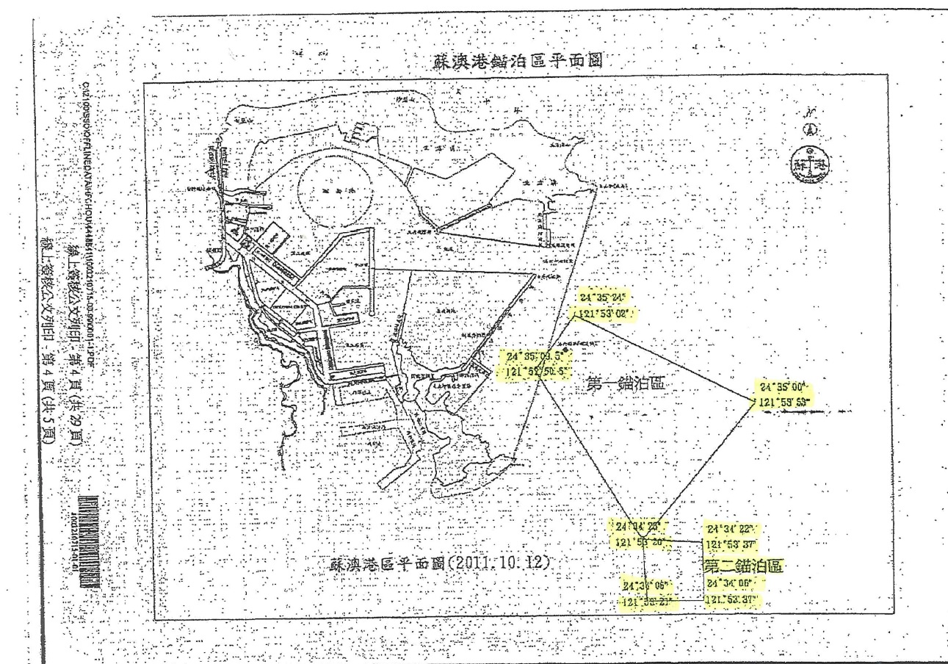
A
C、A
B
D
D
C
B
A
C、A
B
D
D
C
B

